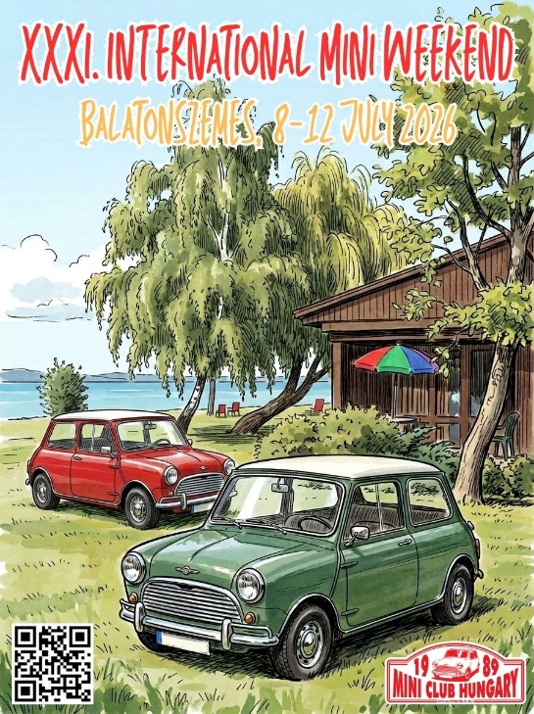 | XXXI. International Mini Weekend  Balatonszemes, Hungary  8-12 July 2026  ACCOMODATION BOOKING

General information

Name
Address
Phone number
E-mail

Booking details

Accomodation type to book | Bungalow | … pc
Accomodation type to book | Bungalow type | …………………
Accomodation type to book | Caravan | … pc
Accomodation type to book | Tent | … pc
Car | … pc
Pet | … pc
Day of arrival
Day of departure
Number of people
- adult
- children
- age of children

Please send this form to info@miniclub.hu not later than May 31!
Accommodation types and prices:

Bungalows:

– Viola 1 Plus: 61.000 HUF (~160 €)*/4 persons/night (1 house available)
– Viola 1 Premium: 59.000 HUF (~155 €)*/4 persons/night (1 house avail.)
– Viola 1: 49.000 HUF (~130 €)*/4 persons/night (11 houses avail.)
– Viola 2: 37.000 HUF (~100 €)*/4 persons/night (12 houses avail.)
– Kamilla: 34.000 HUF (~90 €)*/4 persons/night (4 houses avail.)

*These are avarage prices for 5 nights, daily prices are little lower for the first 2 nights (July 8-9) and little higher for the last 3 nights (July 10-12).

Caravan pitches

– ca. 15.000-20.000 HUF (~40-50 €)/4 persons/night. Calculate your real costs HERE

Tent pitches

– ca. 10.000 HUF (~25 €)/2 persons/night. Calculate your real costs HERE

More about the accomodation types HERE, map of the camping HERE.

Payment and cancellation terms:

Advance payment: 50% based on the confirmation email, which the camping will send directly to you to the email address provided.

Payment options: the remaining amount on site in cash or bank card

Cancellation deadline: 14 days before the start of the meeting (until June 23) can be canceled free of charge, in case of cancellation after that the full accommodation fee must be paid.

More info about the camping: HERE

Any questions: info@miniclub.hu

